Table of Contents
1 Why do ADVANCED ask you to register and qualify? 2
2 What is SAP ARIBA and the ARIBA Network? 2
3 What to do when you receive the invitation email? 2
3.1 First time Ariba registration 2
3.2 Already have an Ariba account 3
4 I already have an Ariba Network account / ANID. 4
5 What to do when I am the wrong person to contact in my company? 5
6 What does it mean when ARIBA says that the link has expired? 5
7 Do I need to provide a DUNS number during registration? 5
8 I forgot my password. What do I do? 6
9 How can I change my email address? 6
10 How do I change my password in ARIBA? 7
11 How to find the Administrator of my company's ARIBA Account? 8
12 How to contact ARIBA Support? 8
13 I have not received an Order from ADVANCED, what should I do? 9
14 How to create and provide access to additional users within the SAP ARIBA supplier account? 9
15 Where can I find my ANID in SAP ARIBA? 10
16 How do I participate in sourcing events via an email invitation and how do I register for the SAP Ariba sourcing event? 10
17 How can I send message via Ariba for an event in Pending Selection status? 11
18 The link in the invitation email has expired. How can I log-in to Ariba portal with a different link? 11
19 Is there any size limitation when attaching a file? 11
20 I have another colleague whom I would like to invite to this RFQ. Can I set-up his account in Ariba? 11
21 Where can I find the event that I am invited to? 11
22 Why can't I find an event? 11
23 I am getting the security warning when I log-in to Ariba. What should I do? 13
24 Need to contact Ariba Helpdesk for assistance. 13
25 Supplier self-registration link for ADVANCED SAP ARIBA 14

ARIBA Supplier FAQ

Why do ADVANCED ask you to register and qualify?

ADVANCED is mandated to actively manage its supplier base, ensuring up-to-date information is available on all its business partners, which includes current certificates as well as address and general business information. This is achieved through a process which is run on SAP ARIBA, the world’s leading purchasing platform.

What is SAP ARIBA and the ARIBA Network?

SAP ARIBA is a cloud-based purchasing platform which enables digital business interaction between suppliers and customers. 3.6 million companies worldwide are already interacting through ARIBA, 2.3 trillion US$ of annual commerce volume is being handled currently. ARIBA Network, as part of the ARIBA product suite, is the central platform that allows Customers and Suppliers to interact. This includes the exchange of business documents (like purchase orders and invoices) as well as general company and marketing information. Basic access to ARIBA Network (which allows receiving and sending of Purchase orders and Invoices) is free of charge. If you wish to further explore technical options, like a full integration of the product into your own ERP and Sales systems, SAP offers various commercial options too.

What to do when you receive the invitation email?

Once you have received the invitation email, there are two possible scenarios:

(a). Your organization does not yet have an Ariba Network Account and needs to register for the first time. Please follow these instructions.

(b). Your organization already has an Ariba Network Account (and an ANID), which you will need to formally link in the registration process. Please follow these instructions.

First time Ariba registration
1) Open the registration email.
Hint: Should you not have received the registration email, please check your SPAM folder.
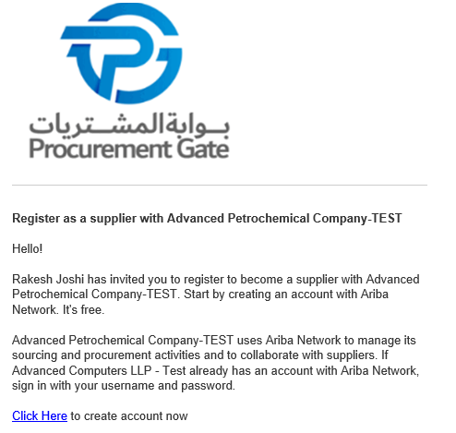
2) Start the registration process by clicking on “Click Here”

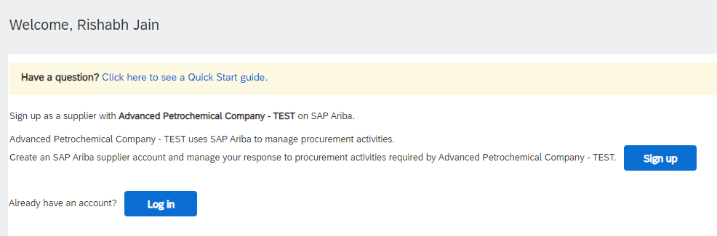

3) Click on “Sign up”.

Already have an Ariba account
Hint: Should you not have received the registration email, please check your SPAM folder.
1) Open the registration email.

2) Start the registration process by clicking on “Click Here”

3) Click on “Log In”.

I already have an Ariba Network account / ANID.

You still need to formally link your ARIBA Network account in the registration process. Please have your User Id and password available and make sure that you are NOT already logged in to your ARIBA Network account when proceeding with the registration process. Please proceed by opening the registration invitation email as described on the above STEPS (Already have an Ariba account).

What to do when I am the wrong person to contact in my company?

Please contact the Category Manager that invited you and request you to set up a different contact. Once this is done, another invitation will be sent to the person that you named.

What does it mean when ARIBA says that the link has expired?
The reason might be that the supplier might have not acted on the link sent from ADVANCED. the link is active for 48 hours and after that, it will expire. So they have to contact advanced to resend a new link again

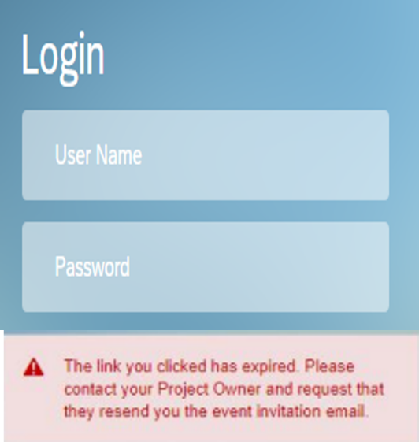
- You click on the link and receive this notification.

- In this case you will most likely already have created a user id and a password.

- The email link will not work anymore.

Please log in with your user credential under "supplier.ariba.com".

Do I need to provide a DUNS number during registration?

No. providing a DUNS number is optional. If you want to provide a DUNS number, but don’t know it, you may search using UPIK.

I forgot my password. What do I do?

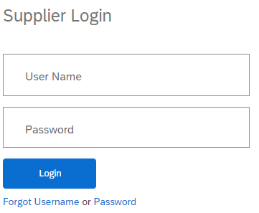

Please follow the link to https://supplier.ariba.com, click on “Forgot username or Password” and follow the instructions on the screen.

How can I change my email address?

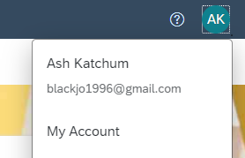
1) Sign in to the Ariba Network with the user you would like to change the email address for. Then click on the initials at the top right corner of the screen and chose the option “My Account”.

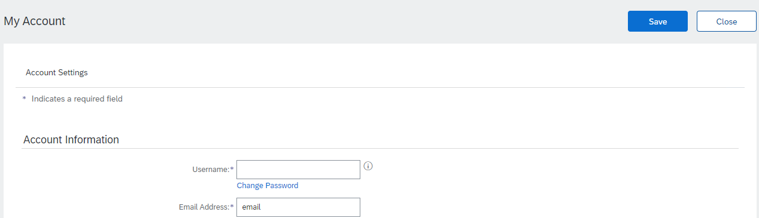
3) Click on “save”.

2) A new window will appear where you can change the email address.

How do I change my password in ARIBA?
1) Please log in to your existing ARIBA Network account, using the username and password that you created when first registering.

2) Now klick on your initials at the top right corner of the screen.

3) Select “My Account”.

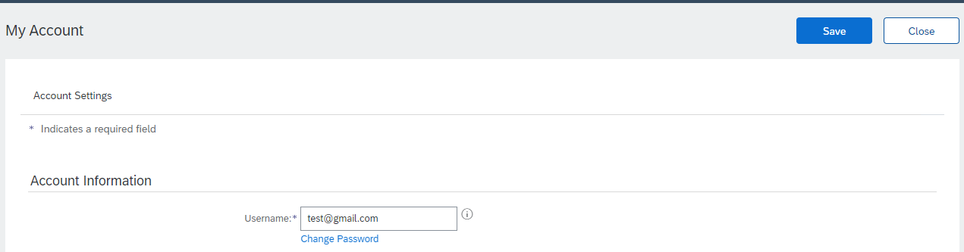

4) You will be led to a configuration page.

5) Click on “change password” below your username.

6) Make sure to click on “Save”.

How to find the Administrator of my company's ARIBA Account?

Sometimes Advanced ARIBA invitations to certain events are sent out to people who are not listed as a user in their company's ARIBA account. Since this is a mandatory prerequisite, you need to initiate this step. The responsible person who can add you as a user for working with Advanced events is the Administrator.

Open your menu and select “Contact Administrator”.

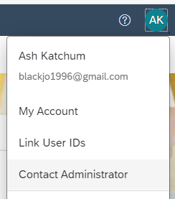

How to contact ARIBA Support?
If you have any problems with your company account, login information or other topics you are very welcome to contact ARIBA via Help Centre which can be accessed under the following link: supplier.ariba.com "?"

Once you have selected the HELP options you can search in the FAQs for a solution or contact ARIBA support.

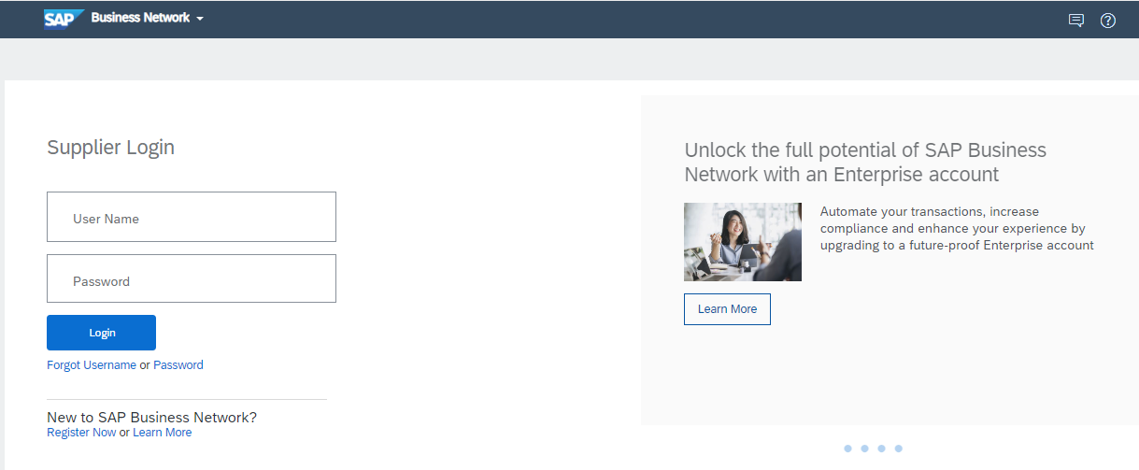

I have not received an Order from ADVANCED, what should I do?

Please contact the ADVANCED representative, with whom a Supplier has contracted work, to confirm if an Order has been created.

How to create and provide access to additional users within the SAP ARIBA supplier account?
Yes, additional users can be added to the SAP Business Network by going to
Settings > Users followed by ‘Create’.

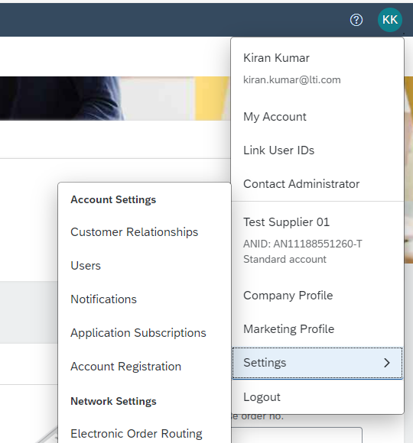

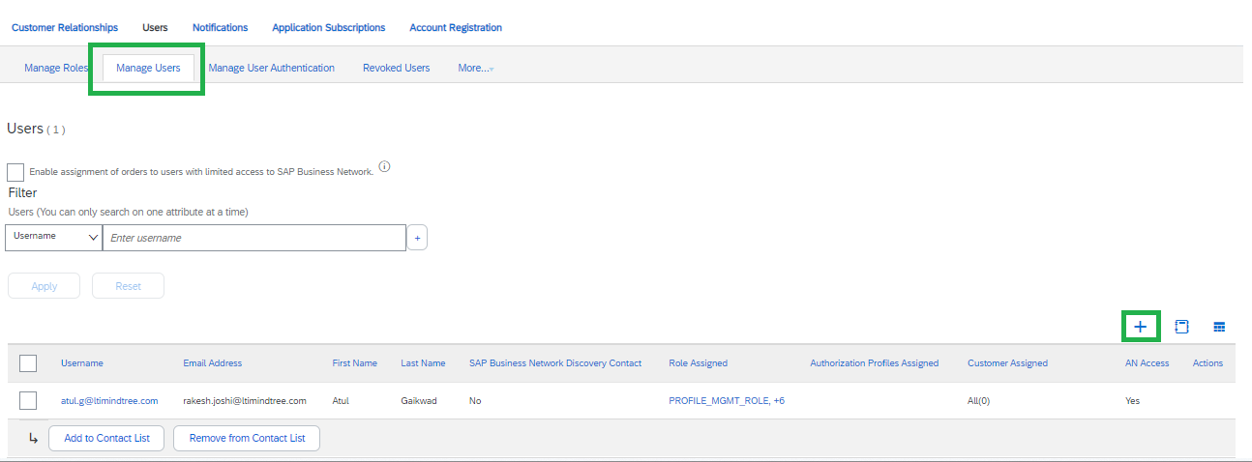

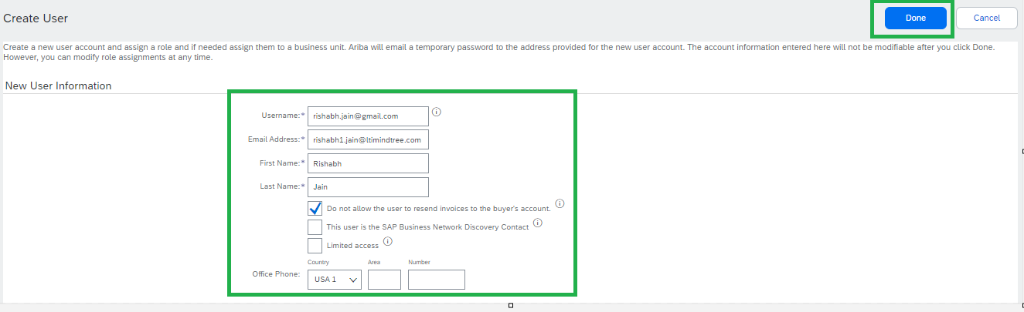

Where can I find my ANID in SAP ARIBA?
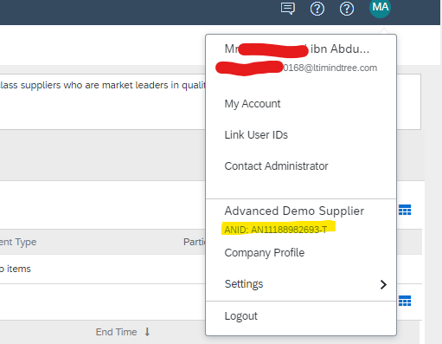

How do I participate in sourcing events via an email invitation and how do I register for the SAP Ariba sourcing event?
Supplier will receive an invitation email from Ariba when they are invited to a specific
event (RFI/RFP/Auction). Supplier is advised to check the spam/junk folders in case the email is not received in the inbox. Open the invite and click on “Click here” hyperlink which will take you to Ariba log-in page. If you are an existing supplier with ADVANCED and have been invited to previous events, enter the username and password to log-in, this will directly take you to the event.

How can I send message via Ariba for an event in Pending Selection status?
Log-in to your event, click on Event Messages from top left of the screen under Event Details. This will open the message board in a live event. You can enter your message and attach any files and click the send button.

Note: you will not be able to send messages for an event with a ‘Completed’ status.

The link in the invitation email has expired. How can I log-in to Ariba portal with a different link?
The link in the invitation email expires within 24 hours after you have accessed the RFx. For subsequent log-in, click on the below URLs: supplier Login. Please bookmark the link for future use.

Is there any size limitation when attaching a file?
Yes, the maximum size allowed to attach is 100mb per file. If the file size is more than 100mb, kindly compress the file size and upload it as a zipped folder.

Note: You can attach any number of files which exceeds more than 100mb in total

I have another colleague whom I would like to invite to this RFQ. Can I set-up his account in Ariba?
Yes, you can set up his/her account in Ariba under the same ANID, however, the new contact will be able to access the tender only after their account is approved by ADVANCED. Please do email the event management team if you have added a new contact to the event. After approval, the ADVANCED Event Management team will add the contact to the RFx.

Where can I find the event that I am invited to?
You can access a sourcing event to which you have been invited via two ways:
- Through the invitation email the buyer sends
- By going to the Proposals page (click app drop-down menu in the upper-left corner of the application and select Ariba Proposals and Questionnaires.)
- From the dashboard, you can find the event that you have been invited to (Status- Open)

Why can't I find an event?
There are several reasons you may not be seeing a sourcing event your company was invited to. Below are various scenarios that may apply:

- Did you receive an event invitation in your email inbox?
Buyers invite suppliers to events by selecting each participant, so there is a chance that only one person from the company received an invitation. Only those who are invited to the event will have access.

If you would like to request an invitation for yourself or additional people from your organization, you will need to contact the project owner.

It is also a common user error to have a typo in the email address field. Doublecheck the email address and if there is a typo the buyer will need to edit it.

- Did you log in to the correct account?
You might have more than one SAP Ariba account. If you have multiple accounts, make sure you are logged into the account that was invited.

- Do you have permissions to see the page?

To view your organization's Ariba Sourcing events, questionnaires, and Ariba Contract Management contracts, documents, and tasks, sub users need to have the permission Access Proposals and Contracts assigned. If you do not have the correct permissions, please contact your administrator. You can find the administrator's contact information by clicking your initials in the upper-right corner of the page and selecting Contact Administrator.

- Is your user activated? Is your profile approved?

It is possible that your user or organization profile is deactivated which will restrict your access to Ariba.

If your organization profile on the buyer's site is Rejected, you will not be able to register. If it is Unapproved, you will be able to register but may not participate in sourcing events.

You must contact your buyer to approve the organization profile.

- Are you on the SAP Ariba Sourcing solution?

If you see Ariba Discovery, Ariba Contract Management, or Ariba Network in the upper-left corner of the application, you are currently accessing another app within your SAP Ariba Commerce Cloud account and will not see the event here. Click the app drop-down in the upper-left corner of the application and select Ariba Proposals & Questionnaires. This action will take you to the SAP Ariba Sourcing platform and show any events to which you have been invited. You may need to switch to the relevant buyer by clicking More... and selecting the correct buyer.

- Is the event in Open status?
In the top right corner of your screen the status will be displayed. If there is a countdown timer, then the event is published/open. If it is Closed, Paused, Pending Selection then you must contact the buyer to open the event.

- Are you locked out of the event?

You will not see the event on your dashboard if the buyer has locked your account from the event. Check your email to see if you were notified of being locked out of the event. In this instance, please contact the project owner to gain access.

- Are you directed to a blank page when you click on an event within your account?

Security features on your computer might cause a blank page when accessing an event. Use the following steps to resolve this issue:

- Check the URL on the blank or black page.
- If the URL starts with HTTP, change this to HTTPS.
- Navigate to the new page.
- Accept any security warnings that appear in your browser.
- Ad Blockers can also cause this issue:
- Check to see if an ad blocker is installed, such as AdBlock Plus and uBlock.
- If one is installed, disable it, and load the page again.
- If neither of these options help, try to log in using a different browser.

I am getting the security warning when I log-in to Ariba. What should I do?

The warning suggests that you may have logged in to Ariba from another laptop/desktop/mobile phone other than the one you had logged earlier, hence discrepancies in the IP address. Go to your browser internet setting and clear temporary files and cache. Close the browser and open again to access Ariba portal.

Need to contact Ariba Helpdesk for assistance.
Provide the Ariba Helpdesk team with the event Doc ID in Ariba - Doc638070532
(example) as reference to get assistance.

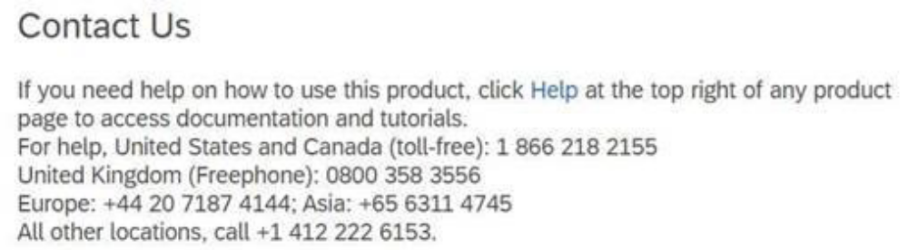

Supplier self-registration link for ADVANCED SAP ARIBA
http://Advanced.sourcing.mn2.ariba.com/ad/selfRegistration/_c_/C2

